BULGAKOV, Mikhail Afanas’evich (БУЛГАКОВ, МИХАИЛ)
(1891-1940)

Russian prose writer and playwright. In the last twenty-five years of the Soviet Union’s existence Mikhail Bulgakov became one of its most widely read and performed writers. This reception, which rescued Bulgakov from near obscurity, occurred posthumously with the partial publication of the novel Master i Margarita (Master and Margarita, written 1928-1940, partially published 1966-7, fully published 1973). Bulgakov experienced severe censorship, especially after the success of his play about a monarchist, Kievan family during the years of the Russian Revolution and Civil War, Dni Turbinykh (The Days of the Turbins, 1926), a play that became the favourite of Joseph Stalin. For the rest of his professional and personal life Bulgakov struggled with the ambivalence of Stalin’s favour: he survived the Stalinist repression that took the lives and productivity of so many of his peers, and yet his works were repeatedly banned. In his writing Bulgakov addressed the moral and personal crises he experienced (war, revolution, censorship, hypocrisy, Soviet ideology, totalitarianism) with a unique mixture of literary fantasy, grotesque, humour, and irony.
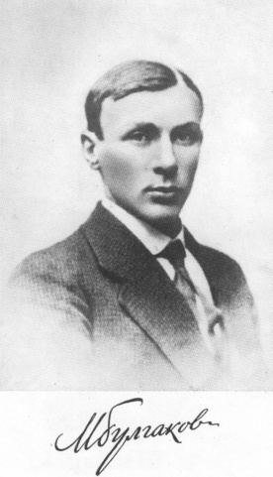Bulgakov as a university graduate in Kiev (1916)

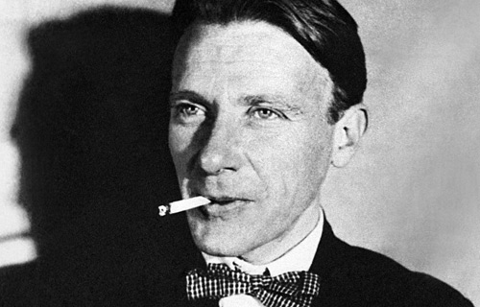
Bulgakov was born 15 May (3 May Old Style) 1891, into a family that belonged to the pre-Revolutionary Russian intelligentsia. Although he was born and grew up in Kiev, he learned the language of the Russian literary canon from an early age. He attended medical school, became a specialist in venereal disease with a private practice in Kiev, and served as a doctor in World War I and during the Revolution in various towns and regions. Bulgakov depicted the cruelty and hypocrisy he witnessed working as a doctor during the Revolution and Civil War in his first literary works “Griadushchie perspektivy” (“Future Prospects,” 1919), “V kafe” (“In the Cafe,” 1920), and later works like Neobyknovennye prikliucheniia doktora (The Unusual Adventures of a Doctor, 1922), Zapiski iunogo vracha (Notes of a Young Doctor, 1925-26), and Morfii (Morphine, 1927). These early themes and images find fullest expression in his play The Days of the Turbins and the novel upon which it is based, Belaia gvardia (White Guard, 1923-24).
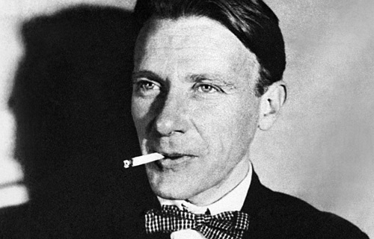
Bulgakov in Moscow (1926)

In September of 1921, as the Civil War drew to its close, Bulgakov moved from Kiev to Moscow, where, having abandoned his medical practice, he found employment at various literary establishments. He wrote short stories and feuilletons during these first, hungry years of the Soviet Union. The ironies of life during the New Economic Policy (NEP, 1921-1928), which began just as Bulgakov arrived from Kiev, inspired short works like “Moskva krasnokamennaia” (“Red-stoned Moscow,” 1922), “No. 13. Dom El’pit-Rabkommuna” (“No. 13. Elpit-Rabkommun Building,” 1922), “Samogonnoe ozero” (“Moonshine Lake,” 1923), Rokovye iatsa (The Fatal Eggs, 1924) and Sobach’e serdtse (The Heart of a Dog, 1925). The end of NEP and the beginning of Stalin’s consolidation of power mark Bulgakov’s move to yet another stage of his oeuvre: in 1928 he began the first sketches of what would eventually become Master and Margarita. Although he worked on that novel until days before his death, he never authorised a final version. In 1939 Bulgakov suffered severe migraines and loss of vision and was diagnosed with malignant nephrosclerosis, the same condition that caused his father’s early death at age 48. He died 10 March 1940.

Between 1926 and his death in 1940 Bulgakov wrote ten original plays Zoikina kvartira (Zoika’s Apartment, 1926), Beg (Flight, 1927), Bagrovyi ostrov (The Crimson Island, 1927), Kabala sviatosh (A Cabal of Hypocrites, 1929), Blazhenstvo (Bliss, 1929), Mol’er (Molière, 1930), Adam i Eva (Adam and Eve, 1930), Poslednie dni (The Last Days, 1934), Ivan Vasil’ievich (Ivan Vasilievich, 1935), Batum (Batum, 1938), a biography of Molière, Zhizn’ gospodina de Mol’era (1933) and among still other literary works, Master and Margarita. Bulgakov never saw most of these works performed or published.

Out of this prolific but increasingly silent period, Master and Margarita, often referred to as his “sunset novel,” ensured Bulgakov’s literary fame. In the novel, an account of the devil’s visit to Soviet Moscow parallels an account of a young Soviet poet’s crisis after hearing the text of a repressed writer recited by the devil. Despite the twenty-six year gulf between the writing of the novel and its reception, readers immediately resonated with the novel’s complex allusions to narratives of Faust and Christ and the works of Russian masters like Pushkin, Gogol, and Dostoevsky, mixed with hilarious parodies of Bulgakov’s contemporary writers. Furthermore, Bulgakov’s innovative use of Moscow as setting quickly produced a number of pilgrimage sites for fans of the novel in the Soviet capital: readers diligently sought out prototypes for Margarita’s mansion, The Spring Ball of the Full Moon, Griboedov House, and especially Apartment 50. Both international and Russian admirers have covered the stairs that lead up to the assumed prototype for apartment 50 at Bol’shaia Sadovaia 10 with images and quotes from the novel for decades. Almost overnight the novel achieved cult status among members of the intelligentsia for its satire of Soviet society and speculative metaphysics, a combination that continues to make Master and Margarita one of the most culturally significant Soviet novels.
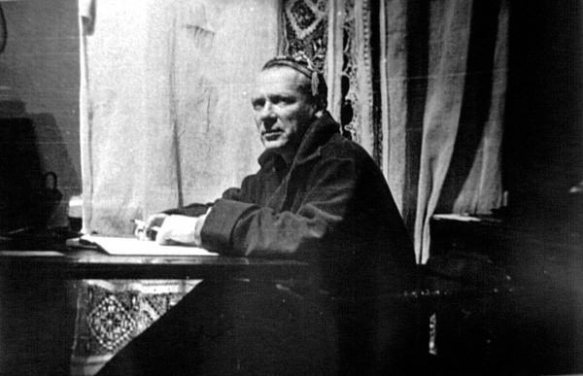
Bulgakov at his writing desk (1936)
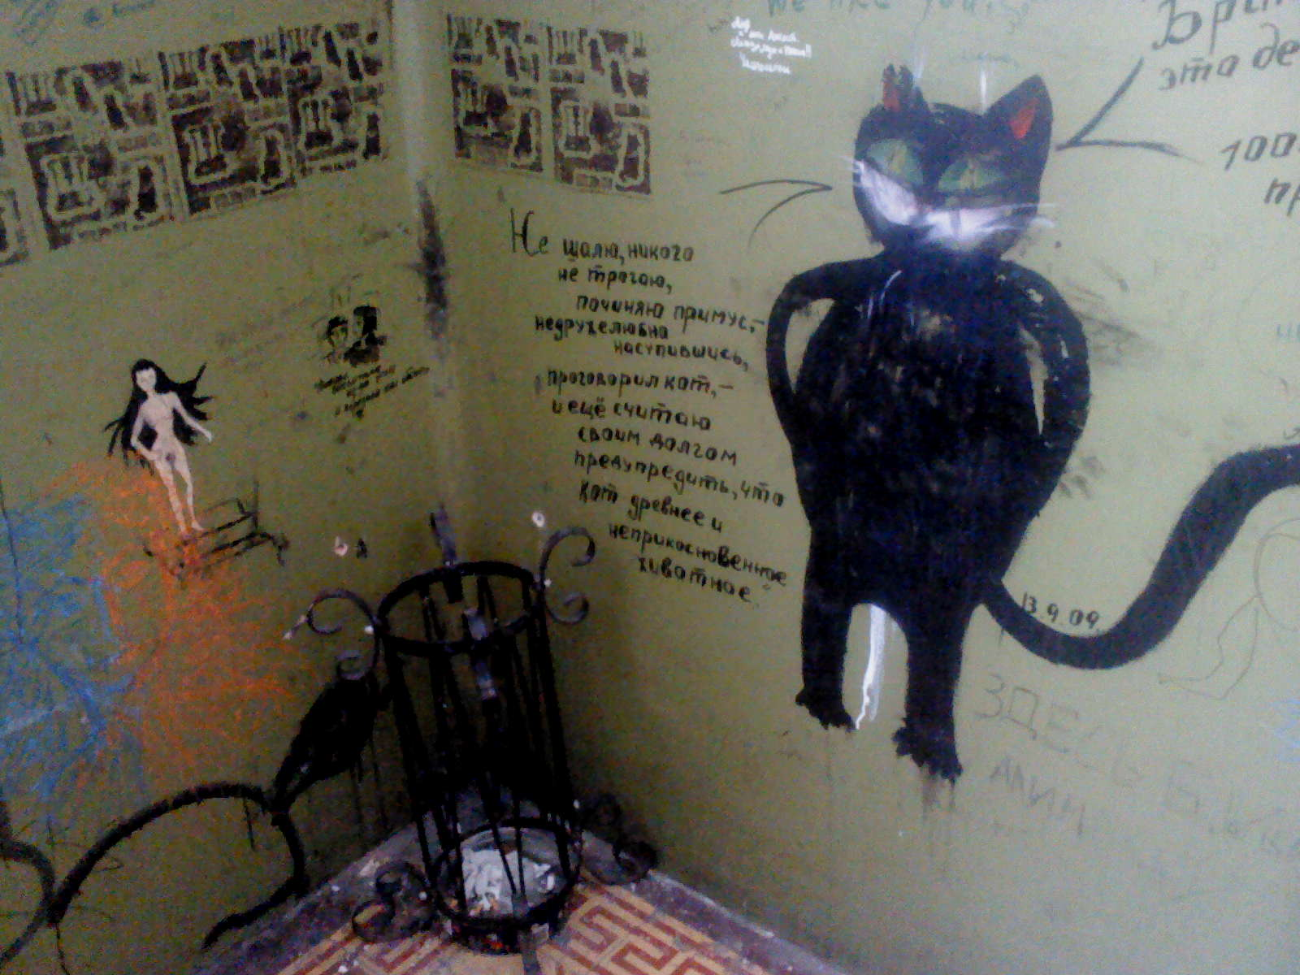
Graffiti in the stairway that leads to Apartment 50, Bol’shaia Sadovaya 10 in Moscow

References and further reading
Works by Mikhail Bulgakov

Selected short stories and feuilletons
“Banshchitsa Ivan” [“The Bania Worker Ivan,” 1925]
“Griadushchie perspektivy” [“Future Prospects,” 1919]
Krasnaia korona [The Red Crown, 1919-20]
“Moskva krasnokamennaia” [“Red-stoned Moscow,” 1922]
Neobyknovennye prikliucheniia doktora [The Unusual Adventures of a Doctor, 1922]
“No. 13. Dom El’pit Rabkommuna” [“No. 13. Elpit-Rabkommun Building,” 1922]
“Psalom” [“Psalm,” 1923]
“Samogonnoe ozero” [“Moonshine Lake,” 1923]
“Stolitsa v bloknote” [“The Capital in a Notebook,” 1922]
“V kafe” [“In the Cafe,” 1920]
Zapiski iunogo vracha [Notes of a Young Doctor, 1925-26]

Novellas
Morfii [Morphine, 1927]
Rokovye iatsa [The Fatal Eggs, 1924]
Sobach’e serdtse [The Heart of a Dog, 1925]

Novels
Belaia gvardiia [White Guard, 1923-24]
Master i Margarita [Master and Margarita, 1928-40]
“Moi bednyi, bednyi master...”: Polnoe sobranie redaktsii i variantov romana Master i Margarita. Ed. V.I. Losev. Moscow: Vagrius, 2006. A complete collection of the manuscript editions of Master and Margarita from 1928 up to Bulgakov’s final edits in 1940.
Zapiski pokoinika (Teatral’nyi roman) [Notes of a Dead Man (A Theatrical Novel), 1936-37]

Plays
Adam i Eva [Adam and Eve, 1930]
Bagrovyi ostrov [The Crimson Island, 1927]
Batum [Batum, 1938]
Beg [Flight, 1927]
Blazhenstvo [Bliss, 1929]
Dni Turbinykh [The Days of the Turbins, 1926]
Ivan Vasil’ievich [Ivan Vasilievich, 1935]
Kabala sviatosh [A Cabal of Hypocrites, 1929]
Mol’er [Molière, 1930]
Poslednie dni [The Last Days, 1934]
Zoikina kvartira [Zoya’s Apartment, 1926]

Other Works
“Chernoe more” [“The Black Sea,” 1937]
“Don Kikhot” [“Don Quixote,” 1938]
“Minin i Pozharskii” [“Minin and Pozharskii,” 1937]
Zhizn’ gospodina de Mol’era [The Life of Lord Molière, 1933]

Letters and Diaries
Curtis, J.A.E. Manuscripts Don’t Burn: Mikhail Bulgakov: A Life in Letters and Diaries. Woodstock, NY: The Overlook Press, 1992. Excellent translations of Bulgakov’s letters and diaries.

Translations into English
BURGIN, DIANA and KATHERINE TIERNAN O’CONNOR, trans. The Master and Margarita. Dana Point, CA: Ardis, 1995. On par with the translation by Pevear and Volokhonsky.
GINSBURG, MIRRA, trans. The Fatal Eggs and Other Soviet Satire, 1918-1963. London: Quartet, 1993.
---, trans. The Heart of a Dog. New York: Grove Press, 1968.
---, trans. The Master and Margarita. New York: Grove Press, 1967. An incomplete translation.
GLENNY, MICHAEL, trans. Black Snow: Theatrical Novel. London: Collins-Harvill, 1996.
---, trans. A Country Doctor’s Notebook. London: Collins-Harvill, 1991.
---, trans. The Heart of a Dog. New York: Harcourt Brace, 1968.
---, trans. The Master and Margarita. New York: Harper and Row, 1967. A complete translation, but lacks the subtlety later translators were able to achieve.
---, trans. The White Guard. New York: McGraw Hill, 1971. An incomplete translation.
PEVEAR, RICHARD and LARISSA VOLOKHONSKY, trans. The Master and Margarita. New York: Penguin, 1997. A very good and complete translation.
PROFFER, ELLENDEA and CARL R. PROFFER, eds. Diaboliad and Other Stories. Carl R. Proffer, trans. Bloomington, IN: Indiana UP, 1972. Adequate translations of many of Bulgakov’s lesser known prose works: “Diaboliad,” The Fatal Eggs, “No. 13. Elpit-
Rabkommun Building,” “A Chinese Tale,” “The Adventures of Chichikov,” “A Treatise on Housing,” “Psalm,” “Four Portraits,” “Moonshine Lake,” “The Raid,” and The Crimson Island.
PROFFER, ELLENDEA, ed. The Early Plays. Carl R. Proffer and Ellendea Proffer, trans.
Bloomington, IN: Indiana UP, 1972. Adequate translations of The Days of the Turbins, Zoya’s Apartment, Flight, The Crimson Island, and A Cabal of Hypocrites.
RICE, ALISON, trans. Notes on the Cuff and Other Stories. Ann Arbor, Michigan: Ardis, 1991. Translations of “Notes on the Cuff,” “Bohemia,” “The Red Crown,” “The Night of the Third,” “Red Stone Moscow,” “The Capital in a Notebook,” “Moscow, City of Churches,” “Moscow Scenes,” “Benefit Performance for Lord Curzon,” “Travel Notes,” “The Komarov Case,” and “The City of Kiev.”
SAUNDERS, NICHOLAS and FRANK DWYER, trans. Zoya’s Apartment: A Tragic Farce in Three Acts. New York: Samuel French, 1991.
SCHWARTZ, MARIAN, trans. White Guard. New Haven, CN: Yale UP, 2008. A very good translation.

Websites
Moshkow, Maksim Eugenievich. “Maksim Moshkow’s Library.” www.lib.ru/BULGAKOW. Links to Bulgakov’s works in Russian and some translations.
Moss, Kevin. “Bulgakov’s Master and Margarita.” Middlebury College. http://
cr.middlebury.edu/public/russian/Bulgakov/public_html. A reliable scholarly website dedicated to Master and Margarita.

Further reading
Biography
MILNE, LESLEY. Mikhail Bulgakov: A Critical Biography. Cambridge: Cambridge UP, 1990. An authoritative critical biography.
Proffer, Ellendea. Bulgakov: Life and Work. Ann Arbor, MI: Ardis, 1984. An important early English-language critical biography written at a time when Bulgakov’s archive was still not completely available to scholars.

Selection of critical works
Barratt, Andrew. Between Two Worlds: A Critical Introduction to The Master and Margarita. Oxford: Clarendon Press, 1987. An important introduction to the political and textual context for Master and Margarita along with an original reading of the novel. Good bibliography.
Curtis, J.A.E. Bulgakov’s last decade: The writer as hero. Cambridge: Cambridge University
Press, 1987. Excellent scholarship on Bulgakov and his creative use of the lives and texts of Molière, Pushkin, and Gogol.
HABER, EDYTHE C. Mikhail Bulgakov: The Early Years. Russian Research Center Studies, vol. 90. Cambridge, Mass: Harvard UP, 1998. Explores autobiographical elements in Bulgakov’s early fiction.
MILNE, LESLEY, ed. Bulgakov: The Novelist-Playwright. Newark, NJ: Harwood Publishing, 1995. Collection of critical essays written for the specialist on various works by Bulgakov.
WEEKS, LAURA, ed. The Master and Margarita: A Critical Companion. Evanston, IL: Northwestern UP, 1996. An anthology of helpful articles covering many aspects of scholarship on Master and Margarita.

Photographs
Miagkov, B.S. and B.V. Sokolov, eds. Mikhail Bulgakov: Zhizn’ i tvorchestvo. Moscow: Ellis Lak, 2006. A comprehensive collection of photographs pertinent to Bulgakov’s life and work.

Films and television series based on Bulgakov’s works
Beg [Flight, film, 1970]
http://www.youtube.com/watch?v=9UGcyweYo2w&feature=plcp
Belaia gvardiia [White Guard, television series, 2012]
Dni Turbinykh [The Days of the Turbins, television series, 1976]
http://www.youtube.com/watch?v=m-it-bNgl14
Ivan Vasil’ievich meniaet professiiu [Ivan Vasilievich Changes Profession, film, 1973]
http://www.youtube.com/watch?v=zuYu9VvvD4w&feature=watch-now-button&wide=1
Master i Margarita [The Master and Margarita, film, 1994 and 2011]
http://www.youtube.com/watch?v=QMby4bQ9qxU
Master i Margarita [The Master and Margarita, television series, 2005]
http://www.youtube.com/watch?v=sOyxpY0oGS4
Morfii [Morphine, film, 2008]
Rokovye iatsa [The Fatal Eggs, film, 1992]
http://www.youtube.com/watch?v=aOjgJ9VrrxU
Sobach’e serdtse [The Heart of a Dog, film, 1988]
http://www.youtube.com/watch?v=whHySar4EoY&feature=watch-now-button&wide=1

Sidney Dement, Binghamton University

SOURCE URLS FOR IMAGES
(http://bulgakovmuseum.ru/bulgakov#)
http://graffiti.livdis.com/blog/view?id=26838

